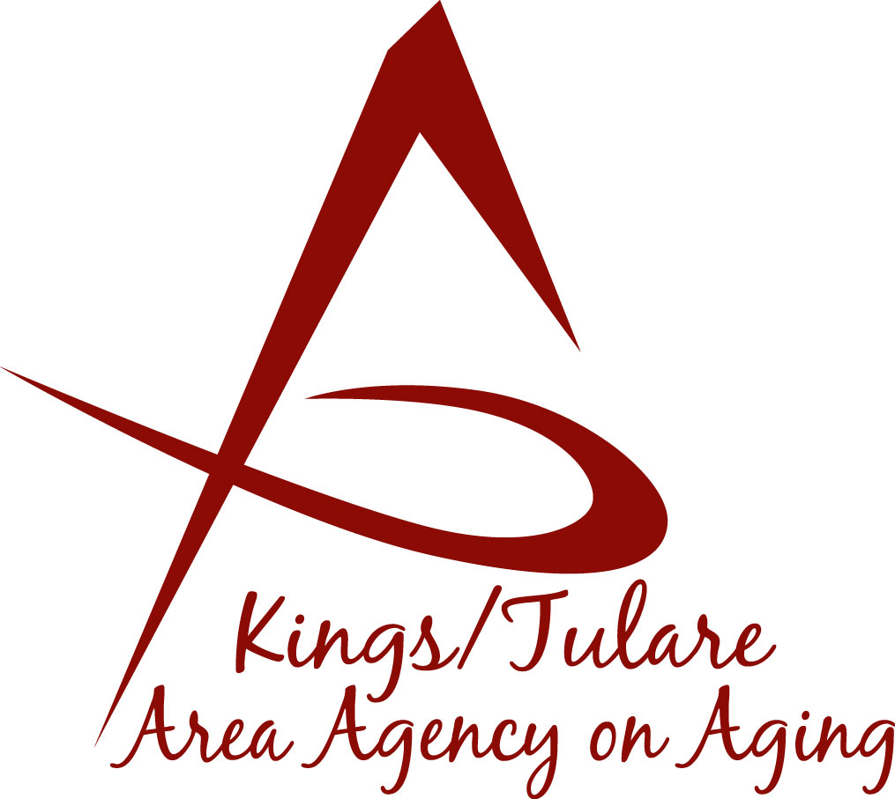ADVISORY COUNCIL AGENDA
Monday, April 22, 2019
10:00 a.m.
Lindsay Senior Center
911 North Parkside
Lindsay, CA 93247

- Call to Order Action

- Introductions of Guests and Council Members Information

3. Public Comment 3 minutes
Any person may directly address the Council at this time on any item on the Agenda or any other items of interest to the public that are within the subject matter jurisdiction of the K/TAAA.

4. Approval of Minutes Action
Members present at the previous meeting may comment or correct minutes from the meeting held on March 18, 2019.

5. Announcements and Correspondence Information

6. Milestone Updates Information
Information regarding current and former members of the Council

7. Senior Day in the Park Information
Reminder

8. Annual Form 700 and Ethics Training (required every 2 years) Information
On-line Ethics training

9. Review of Orientation Manual and Bylaws Information

11. Staff Reports Information

12. Development of the May 2019 Council Agenda Information

13. Additional Member Comments Information

14. Adjourn Action
If there is no further business to attend to, members may adjourn the meeting at this time.
Notice to the Public
In compliance with the Americans with Disabilities Act, if you need special assistance to participate in this meeting, please contact Christine Tidwell at (559) 624-8063.
The disclosable public records related to this agenda are available for public inspection at the reception area of the Tulare County Human Services Government Plaza building, 5957 S. Mooney Blvd. Visalia, CA 93277

